**1629B65 Richard White of Egham TS draft SG.docx**

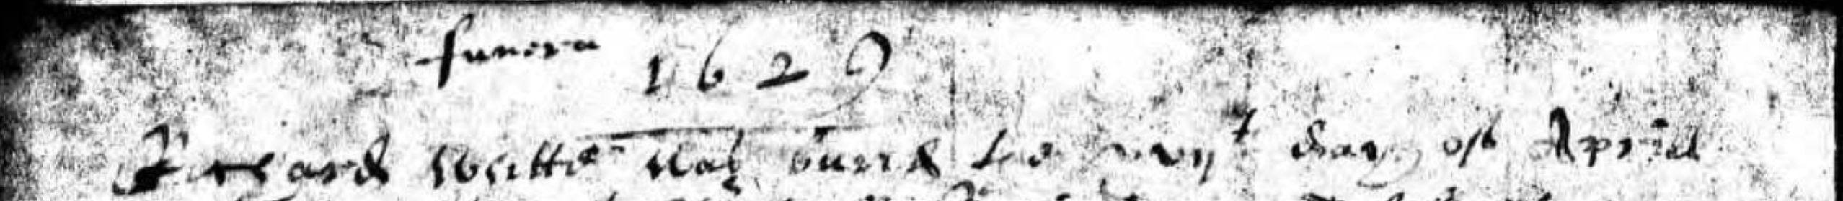

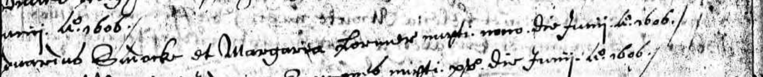

**N.B.**

* **The will is written on 18 April but is not signed. Maybe nuncupative but this is not stated**
* **The parish register states that Richard White was buried on 17 April 1629 (see above)**
* **Edward Sudacke married Margery on 9 June 1606**

**WILL**

**In the name of god amen I richard white of Egham in the Counte of Surrey**

**husbandman bequethe my soule to Almightie god and my boddye to the Earth**

**in perfect memory god be thanked heere I make my Last will and testament**

**this xviijth of Aprill in the yeare of oure Lord god 1629. Item I geaue my**

**Free holde house and and land to my Daughter Jone white as stoode in**

**the parishe of Egham to shee and her Eyres for ever when shee Comes**

**of the Eage of xxj yeares and I macke my wyfe mary white my**

**Full xecutor In the p[re]sentes of**

**Edward Saddack**

**Henry Strode [mark]**

**Edward Saddack....**

**....Bricklayer**

**An Inuentory of the goodes & Chattles of Richard white**

**late deceased of the p[ar]ish of Egham in the County of**

**Surrey taken and praised the xviijth day of May**

**1629 By vs whose names are hervnder written**

|  |  |
| --- | --- |
| **Inprimis his purse & wearing app[ar]ell** | **vjs viijd** |
| **In the hall an ould table & a Co[ur]t Cupbord**  **a forme & a litle Copborde** | **xjs** |
| **It[em] In the Chamber A bedstead & a Cou[er]lett sheete &**  **other ould beding** | **vjs viijd** |
| **It[em] three litle Chestes & a litle ould bedstead** | **vijs** |
| **It[em] a spad[e] & an Axe w[it]h other small tooles** | **iijs iiijd** |
| **In the kitchen** |  |
| **It[em] a table & a forme & 2 benches** | **xs** |
| **It[em] 2 linnen wheeles & two drinking? tubbes**  **& a bucking tubb w[it]h a trough & an ould**  **barrell & a litle couer? & a planke**  **w[it]h some other smal thinges** | **vijs** |
| **It[em] A vice** | **iijs iiijd** |
| **It[em] A Brass pott & a Ketle w[it]h an Iron pott**  **& one pewter platter** | **vijs** |
| **Sumatotalis** | **lvjs** |

**Robte Chandler**

**his m[ar]ke**

**Robte White**

**his m[ar]ke**

**John Fletcher**