**1629B65 Richard White of Egham**

**[1629B65 Richard White of Egham TS draft SG Checked MJ and CF Ancestry Final.docx. Transcribed by Sally Gardiner. Draft submitted 25 October 2021, checked by MJ against Ancestry 21 March 2023, resubmitted as checked 24 March 2023] Ancestry checked 8 July 2024**

**NOTES**

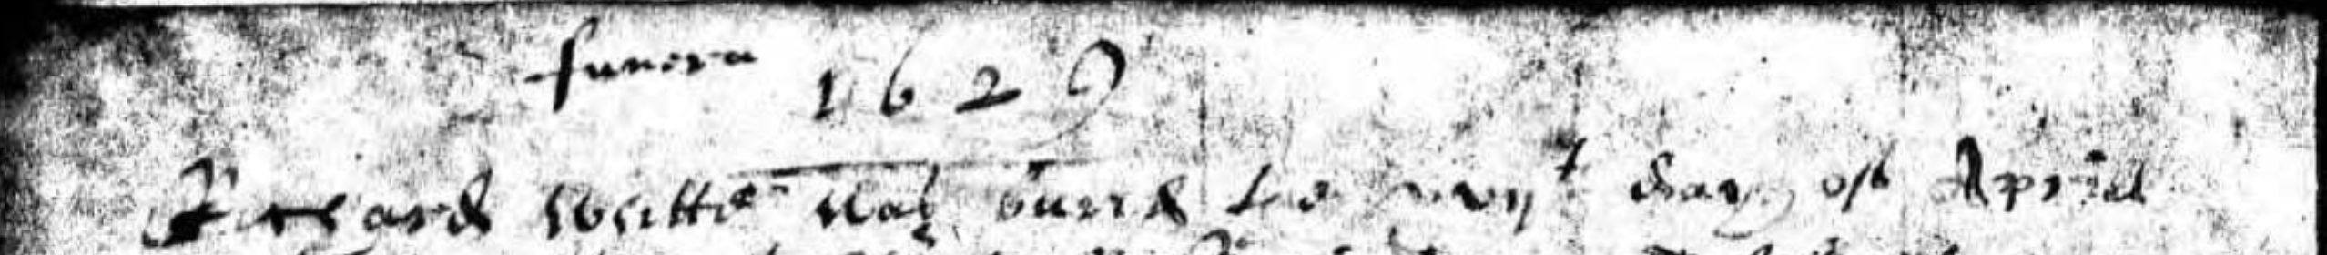

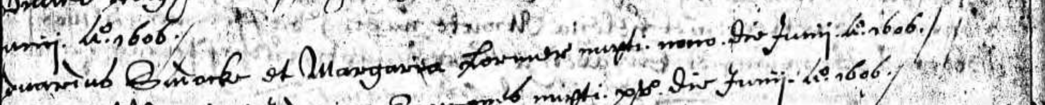

**N.B.**

* **The will is written on 18 April but is not signed. Maybe nuncupative but this is not stated**
* **The parish register states that Richard White was buried on 17 April 1629 (see above)**
* **Edward Sudacke married Margery on 9 June 1606**

**WILL**

**1629B65/1**

**In the neame of god amen I Richard white of Egham in the Counte of Surre[y]**

**husbandman bequethe my soule to all mightie god and my boddye to the Earthe**

**in perfet memory god be thancked heare I macke my Last will and testetament**

**this xviijth of Aprill in the yeare of oure Lord god 1629 Item I geaue my**

**Free holde house and and land to my daughter Jone white at strode in**

**the parishe of Egham to shee and her Eayres for ever when shee Comes**

**of the Eage of xxj yeares and I macke my wyfe mary white my**

**Full xecutor In the p[re]sentes of**

**Edward Saddack**

**Henry Strode *[mark]***

***Latin Probate undated***

***granted to Edward Saddack of the same place, bricklayer***

**1629B65/2**

**An Inuentory of the goodes & Chattles of Richard white**

**late deceased of the p[ar]ish of Egham in the County of**

**Surrey taken and praised the xviijth day of May**

**1629 By vs whose names are hervnder written**

**Inprimis his purs & wearing app[ar]ell vjs viijd**

**In the hall an ould table & a Co[u]rt Cupbord**

**a forme & a litle Copborde xjs**

**It[em] In the Chamber A bedstead & a Cou[er]lett sheete &**

**other ould beding vjs viijd**

**It[em] three litle Chestes & a litle ould bedstead vijs**

**It[em] a spad & an Axe w[it]h other small tooles iijs iiijd**

**In the kitchin**

**It[em] a table & a forme & 2 benches vs**

**It[em] 2 linnen wheeles & two drinking tubbes**

**& a bucking tubb w[it]h a trough & an ould**

**barrell & a litle co[…]r & a planke**

**w[it]h some other smale thinges vijs**

**It[em] A vice iijs iiijd**

**It[em] A Brass pott & a Cetle w[it]h an Iron pott**

**& one pewter platter vijs**

**Sumatotalis lvjs**

**Rob[er]te Chandler**

***[mark]***

**his m[ar]ke**

**Rob[er]te White**

***[mark]***

**his m[ar]ke**

**John Flercher**